Samsung 980 PRO with Heatsink 2TB PCIe 4.0 NVMe SSD M.2 2280 | PS5 Compatible MZ-V8P2T0

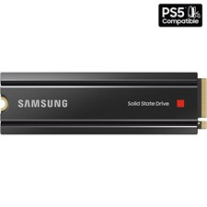

**Key Specifications**

* **Capacity**: 2TB
* **Interface**: PCIe Gen 4.0 x4, NVMe 1.3c
* **Form Factor**: M.2 2280
* **Sequential Read Speed**: Up to 7,000 MB/s
* **Random Read (4KB, QD32)**: Up to 1,000K IOPS
* **Random Write (4KB, QD32)**: Up to 1,000K IOPS

**Performance Features:**

* **Heatsink Integration**:  
  Ensures efficient heat dissipation for sustained performance during prolonged use, preventing thermal throttling.
* **Gaming-Optimized**:  
  Experience faster load times and seamless gaming with high read/write speeds and low latency.
* **PlayStation 5 Ready**:  
  Meets and exceeds Sony's requirements for PS5 storage expansion, allowing quick and easy installation.

**Warranty:**

* Backed by a **5-year limited warranty**, ensuring dependable support and peace of mind.